CS 305 Project One

Document Revision History

Version | Date | Author | Comments
1.0 | 03-21-26 | [Lawrence Langelier]

Client



Instructions
Submit this completed vulnerability assessment report. Replace the bracketed text with the relevant information. In this report, identify your security vulnerability findings and recommend the next steps to remedy the issues you have found.

- Respond to the five steps outlined below and include your findings.
- Respond using your own words. You may also include images or supporting materials. If you include them, make certain to insert them in the relevant locations in the document.
- Refer to the Project One Guidelines and Rubric for more detailed instructions about each section of the template.

Developer
[Lawrence Langelier]

1. Interpreting Client Needs
Determine your client’s needs and potential threats and attacks associated with the company’s application and software security requirements. Consider the following questions regarding how companies protect against external threats based on the scenario information:

- What is the value of secure communications to the company?
- Are there any international transactions that the company produces?
- Are there governmental restrictions on secure communications to consider?
- What external threats might be present now and in the immediate future?
- What modernization requirements must be considered, such as the role of open-source libraries and evolving web application technologies?

[Artemis Financial is a consulting company that creates financial plans for customers, including retirement, investments, savings, and insurance planning. Because the company handles sensitive financial and personal information, secure communication is extremely important. Data sent between users and the application must be protected so attackers cannot intercept or change it. If communication is not secure, customer information could be exposed, which could lead to financial loss and damage to the company’s reputation.
The application uses a RESTful API, which allows users and systems to send requests and receive data over the internet. While this makes communication easier, it also creates entry points that attackers could try to exploit. Because of this, the application must properly validate input and secure its API endpoints. There are also potential external threats such as stolen credentials, malicious input, and attacks targeting outdated software libraries. Since the system relies on modern web technologies and open-source libraries, it is important to follow secure coding practices and regularly update dependencies to protect the application from security risks.
]

2. Areas of Security
Refer to the vulnerability assessment process flow diagram. Identify which areas of security apply to Artemis Financial’s software application. Justify your reasoning for why each area is relevant to the software application.

[Several areas of security apply to Artemis Financial’s web application because it accepts external input, communicates over the internet, and handles sensitive financial data. Input validation is important because the application receives user input through API requests. If this input is not validated, attackers could send harmful or unexpected data into the system.
API security is also important because the application is built using a RESTful API. Endpoints allow users to send requests and receive responses from the server, which creates entry points that could be abused if they are not properly secured. Client/server interaction is another key area because the system constantly sends and receives data across the internet, which means communication must be protected.
Error handling and code quality are also relevant. For example, exposing system errors or using insecure coding practices could reveal information about how the system works. Encapsulation helps protect sensitive data within the application by preventing direct access to important variables or components. Finally, authentication and authorization are critical because the application must control who can access financial information and system features.
]

3. Manual Review
Continue working through the vulnerability assessment process flow diagram. Identify all vulnerabilities in the code base by manually inspecting the code.

[By manually reviewing the code base and following the vulnerability assessment process flow diagram, several security risks were identified in Artemis Financial’s application.

1. Hardcoded database credentials
Where found: DocData.java
Example code:
Connection con = DriverManager.getConnection(
"jdbc:mysql://localhost:3306/test","root","root");
Why this is a risk:
The database username and password are written directly in the code. Anyone with access to the code can see these credentials. Using the root account also gives full database access, which increases the impact if the system is compromised.
2. Unsafe error handling using printStackTrace()
Where found: DocData.java
Example code:
catch(SQLException e) {
e.printStackTrace();
}
Why this is a risk:
printStackTrace() exposes internal system information such as file paths, class names, and application structure. Attackers could use this information to understand how the system works and identify additional vulnerabilities.

3. Lack of input validation
Where found: GreetingController.java
Example code:
@GetMapping("/greeting")
public Greeting greeting(@RequestParam(value = "name", defaultValue = "World") String name) {
Why this is a risk:
The application accepts user input through the name parameter without validating or sanitizing it. Attackers could send unexpected or malicious input. If the application later processes this input in other parts of the system, it could lead to injection attacks or application errors.
4. Public API endpoint exposed
Where found: GreetingController.java
Example code:
@GetMapping("/greeting")
Why this is a risk:
This endpoint is publicly accessible and does not require authentication or authorization. Anyone who knows the endpoint URL can send requests to the system. In a financial application, exposing endpoints without access control could allow unauthorized users to interact with system functions.
5. No authentication or authorization controls
Where found: GreetingController.java
Example code:
@RestController
public class GreetingController {
Why this is a risk:
The controller does not implement any authentication or authorization checks. There is no security framework verifying the identity of users before allowing access to the endpoint. This means unauthorized users could potentially access system functionality that should be restricted.
6. Outdated third-party dependencies
Where found: pom.xml
Example dependencies:
Bouncy Castle
Spring Boot
SnakeYAML
Why this is a risk:
Outdated dependencies may contain known vulnerabilities. Attackers often target older libraries because their weaknesses are publicly documented in vulnerability databases.
7. Large file upload configuration
Where found: application.properties
Example configuration:
# Max file size.
spring.servlet.multipart.max-file-size=200MB
# Max Request Size
spring.servlet.multipart.max-request-size=215MB
Why this is a risk:
Large upload limits may allow attackers to upload extremely large files. This could overload the server and potentially cause denial-of-service conditions.

8. Direct database access without connection management
Where found: DocData.java
Example code:
Connection con = DriverManager.getConnection(
"jdbc:mysql://localhost:3306/test","root","root");
Why this is a risk:
The application connects to the database using the root account, which has full administrative privileges. If the application is compromised, an attacker could gain full control of the database. Applications should use limited-privilege service accounts instead of administrative accounts.

9. Poor code structure and placeholder logic
Where found: Controller logic
Example code:
return new Greeting(counter.incrementAndGet(), String.format(template, name));
Why this is a risk:
The user input value is inserted directly into the response using String.format(). If user input is not properly validated or sanitized, malicious input could be reflected in application responses.

10. Lack of secure communication enforcement
Where found: Application configuration
Example behavior:
The application does not explicitly enforce HTTPS or secure transport for communication.
Why this is a risk:
If communication is not encrypted, attackers could intercept or modify sensitive financial data during transmission.

4. Static Testing
Run a dependency check on Artemis Financial’s software application to identify all security vulnerabilities in the code. Record the output from the dependency-check report. Include the following items:

- The names or vulnerability codes of the known vulnerabilities
- A brief description and recommended solutions provided by the dependency-check report
- Any attribution that documents how this vulnerability has been identified or documented previously

I integrated the OWASP Dependency-Check plug-in into the Maven project and ran a static dependency scan on Artemis Financial’s application. The tool compared project dependencies against the National Vulnerability Database (NVD) to identify known security vulnerabilities. The scan found 11 vulnerable dependencies with 152 total vulnerabilities, many with high or critical severity.

One dependency identified was bcprov-jdk15on version 1.46, part of the Bouncy Castle cryptography library. The report listed vulnerabilities such as CVE-2016-1000338 and CVE-2020-15522, which involve issues with signature verification and potential denial-of-service risks. The recommended solution is to update the Bouncy Castle library to a newer secure version.

Another dependency identified was jackson-databind version 2.10.2, which had multiple vulnerabilities including CVE-2020-25649 related to XML external entity attacks. Because this library processes JSON data, a vulnerability could affect how application data is handled. The recommended solution is to update Jackson Databind to a patched version.

The report also identified vulnerabilities in hibernate-validator 6.0.18.Final, snakeyaml 1.25, spring-boot 2.2.4.RELEASE, spring-core 5.2.3.RELEASE, spring-web 5.2.3.RELEASE, and tomcat-embed-core 9.0.30, many of which were classified as critical severity. These libraries support core functionality such as validation, configuration handling, web processing, and the embedded web server.

The dependency-check report attributes these vulnerabilities through CVE records, package identifiers, vendor advisories, and security databases such as the National Vulnerability Database. The recommended solution for these issues is to update the affected dependencies to newer versions that include security patches.

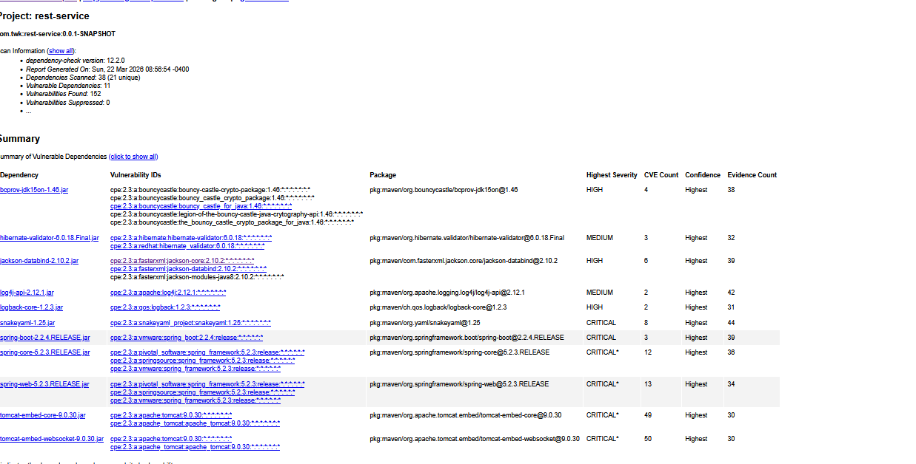

5. Mitigation Plan
Interpret the results from the manual review and static testing report. Then identify the steps to mitigate the identified security vulnerabilities for Artemis Financial’s software application.

After completing both the manual code review and the static testing using the OWASP Dependency-Check tool, security risks were identified from two different areas. The manual review focused on how the code is written and how the application handles user input, authentication, and error handling. The static testing focused on identifying known vulnerabilities in third-party libraries used by the application.
The manual review revealed issues such as hardcoded database credentials, lack of input validation, unsafe error handling using printStackTrace(), and unsecured API endpoints. These risks could allow attackers to send malicious input or access sensitive information. These issues can be reduced by removing hardcoded credentials, validating user input, improving exception handling, and implementing authentication and authorization controls.
The static testing results showed that several dependencies used by the application contain known vulnerabilities. The scan identified 11 vulnerable dependencies with 152 total vulnerabilities, many with high or critical severity. These vulnerabilities affect components such as JSON processing, validation libraries, configuration handling, the Spring framework, and the embedded Tomcat web server. The recommended solution is to update these dependencies to newer versions that include security patches.
Both approaches help identify different types of risks. Manual review identifies coding mistakes, while static testing identifies known vulnerabilities in external libraries. Addressing both types of issues together will improve the overall security of the application.

